Tennessee Arts Academy
February 24, 2024 (10:45-12:15)
Rob Amchin
@robamchin.com
robamchin@gmail.com
Check out my Patreon site for more materials to share with your classes and to inspire you for your own creative ideas!

Theme 2—Move it!—Listening activities with movement and virtual dancing
Description: Incorporating movement activities in your general music classroom—creative movement to listening lessons to folk dance and everything in between. Models, processes, and reflections on the importance of active learning in your classroom.

Legato movement
Skating—Charlie Brown Christmas—Vince Guaraldi Trio
Lamentation—Languente miseris (Arr. for Recorder Ensemble)
Recording: B-Five Recorder Consort & Johannes Weiss
Form: Through composed
Instrumentation: Recorder quartet

I giorni—Angèle Dubeau & La Pietà— Ludovico Einaudi: Portrait (Deluxe Edition)
Cavatina (From The Deer Hunter)—John Williams, Laurence Cottle, Ralph Salmins, Harold Fisher, Ian Thomas & Chris Laurence Quartet. John Williams plays the Movies

Legato songs to move to

Chairs to Mend

Oh, How Lovely Is the Evening

Staccato Movement
Popcorn—Hot Butter
(It’s Gonna Be) Okay—The Piano Guys
“Thulele Mama Ya” from A Whole New Way of Getting Dressed by Coco’s Lumch
“Locke: Saraband” from An Excess of Pleasure, Palladian Ensemble

Staccato Songs

Frog in the middle

Telephone Game—With a rick-tick tickety tick
s m s s l s te l s
Hey Rob, I think I hear my name.
s m s s l s te l s
Hey Rob, I think I hear my again
s m s l s te l s
You’re wanted on the Telephone.
s s m s l s s te l s
If it isn’t ______ I’m not at home
s s m s te s l s s m
With a rick tick tickety tick (Oh Yeah)
s s m s te s l s s m
With a rick tick tickety tick (Oh Yeah)

Listening Pieces

“Flote Und Pauke Musica Poetica”—The Orff-Schulwerk (Disc 2, track 7)
A (Non-locomotor movement–Movement in place)
Picking apples in the orchard.
Would you like a red delicious?
Picking apples in the orchard,
Maybe you would like some too!
Picking apples all day long!

B (Locomotor movement—Movement way from “the space”)
Yes, I would! Yes, I would!
Let’s go walking through the orchard!
Yes, I would! Yes, I would!
Let’s go get a basket full!

Extension: Different kinds of apples to create word chains.

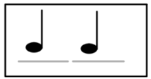 | 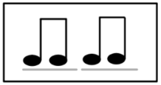 | 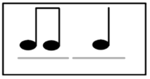 | 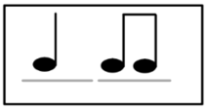 | 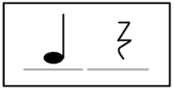
Fuji | Red delicious | Granny smith | Pink Lady | Jazz

J.S. Bach (1685-1750)

Orchestral Suite #3 In D, BWV 1068 – Gavotte
Form:
Several possibilities/analysis

A—Episodes—A
OR
(ABC) DEF (interlude) GH (AABBC)
Instrumentation:
Baroque orchestra

- Using building blocks, can we learn the rhythm (below) through echoed imitation. Can we analyze the piece? Notice how it starts as a question and answer but then adds some extra notes at the end.
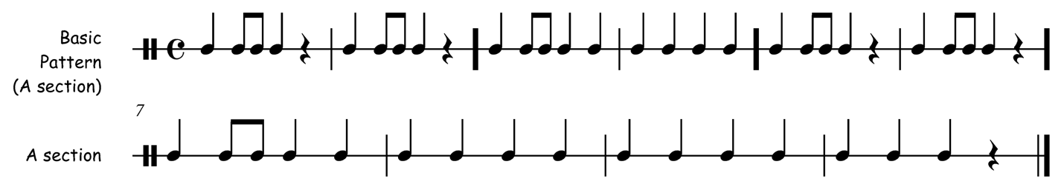

Concerto for Violin and Strings in E, Op.8, No.1, R.269 "La Primavera": 1. Allegro Rondo
Form:
Rondo
Instrumentation:
Baroque Orchestra

- Learn the text to the “A” section.
- Follow along with the music, adding the chant for the “A” sections when they happen.

A—Tutti “We’re glad springtime is here!”
We’re glad that springtime is here!
We’re glad that springtime is here!
It’s my favorite time of year!
We’re glad that springtime is here!
We’re glad that springtime is here!
It’s my favorite time of year!

Let’s watch all the flowers growing.
Let’s watch all the flowers growing.
It’s spring time!
Our favorite time of the year! (2X)

B— Duet between Violins—Flowers growing/mirror movement

A—Tutti
Let’s watch all the flowers growing.
Let’s watch all the flowers growing.
It’s spring time!
Our favorite time of the year!

C—Quiet—spirals move as a solo or small group

A—Tutti a with development a (tutti)

D—Strong 16th notes. Loud fast motions

A—Tutti
Let’s watch all the flowers growing.
Let’s watch all the flowers growing.
It’s spring time!
Our favorite time of the year! (2X)

E—Solo/duet-legato growing into a bouquet of flowers/emerging/stretching from the ground

A—Tutti
Let’s watch all the flowers growing.
Let’s watch all the flowers growing.
It’s spring time!
Our favorite time of the year! (2X)

Dances

Les Saluts
Source(s): Rhythmically Moving 1, track 15
Formation: Circle
Directions: (A) Walk R long phrase (16 bts)(B) Walk L long phrase (C) In, out, in hold, out

Seven Jumps Denmark/Germany Kimbo Records (KEA 1146), International Folk dance Mixer, track 6, Rhythmically Moving 2, track 2
Formation: Circle
Walk R phrase one
Walk L phrase 2
Seven steps: (legs up R, then L) Knees (R, then L), Elbows (R, then Left), head

Alewander

Create your own dance using pathways—Alewander

Tänze Für Kinder Und Jugendliche—Hermann Urabl / Martin Wey

“Alexander” In Shenanigans Vol. III - Folk Dances Of Terra Australia

Wrap Up
Where did we go today and how will you expand on these ideas this year?

Connect: How are the ideas and information presented CONNECTED to what you already knew?

Extend: What new ideas did you get that EXTENDED or pushed your thinking in new directions?

Challenge: What is still CHALLENGING or confusing for you to get your mind around? What question, wonderings, or puzzles do you now have?

