Tennessee Arts Academy
February 24, 2024 (9:00-10:30)
Rob Amchin
@robamchin.com
robamchin@gmail.com
Check out my Patreon site for more materials to share with your classes and to inspire you for your own creative ideas!

Theme 1—Same and Different—Exploring Opposites
Description: High and Low/Fast and Slow/Same or Different—Explore musical and movement contrasts in this active learning session of singing, dancing and integrated arts for your general music classroom. Ideas for using this theme throughout your year.

Opening Music for Movement—Can you find the contrasts and opposites?

Chick Corea—El Bozo, Pt. 1 (fast and slow)

Bartok—Evening in the Village (fast and slow)

Compagnie Maître Guillaume (from Musiques à danser de la renaissance)—Pavane et gaillarde des dieux (changing meters)

Anadolu Kavagi (Turkish Music) (from Alleys of Istanbul by Turku) (Duple and triple meter and tempo changes)
Beatles—Hello, Goodbye (Lennon and McCartney)

Recorder Improvisations—Opposites by Rob

Kreutztanz (Cross dance) (tempo changes)—We will explore this with movement today.

Activity: React to the different tempi (and changing tempi!) through movement

Double-Double
Double-Double This This,
Double-Double That that,
Double this, double that,
Double this that!

Activities: Try the traditional hand clapping game.
Pat the repeated words and clap the “th” words.
Try in canon.

Poems of opposites
Rain on the roof tops
Rain on the trees,
Rain on the green grass
But not on me!

“Mother May I go and swim?
“Yes, my darling daughter,
Hang your clothes on yonder limb
But don’t go near the water.“

Activities: Find the opposites.
Add motions to the poems

Up and Down and Around by Catherine Ayres
(a book for kindergarten)
Stretch up and stretch down (and all around).
Activity: Stretch your body stall and short while reading.

One summer in the garden (Gertrude Orff)

Activity: Add new words to this that are opposites

Way Down South
Way down way down South where bananas grow
A grasshopper stepped on an elephant’s toe
The elephant said with tears in his eyes,
“Pick on somebody your own size!”

Change the words for opposites.
Way down way down South where ???? grow
A ???? stepped on an ????’s toe
The ???? said with tears in his eyes,
“Pick on somebody your own size!”

The opposite game (talking about starting recorder)

Ideas about improvisation—Question and Answer Activities
Comparing echoing to improvising in question and answer.
Try with clapping patterns, first echoing and then changing one element (adding a rest, for instance) to create an “answer.”
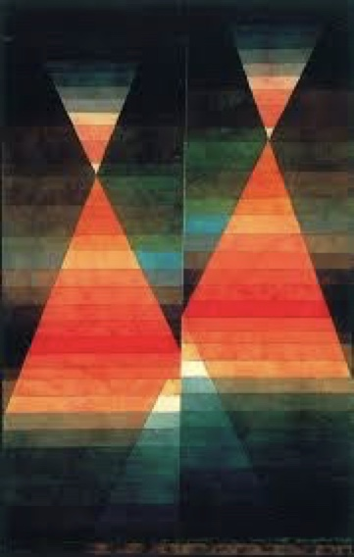

Krebspolka—FidulaFON 1260
Formation: Partners
- Step forward with partner 1-2-3-4
Gallop backward with quick steps (gallop-gallop-gallop-gallop)
- Improvise (find a new partner)

Positive and Negative Space (visual arts)
Try to recreate what you see in the pictures.
Do they move? How would you move to realize the picture?
What would be the opposite motion to what you created?
Can you do this with a partner or in small groups?
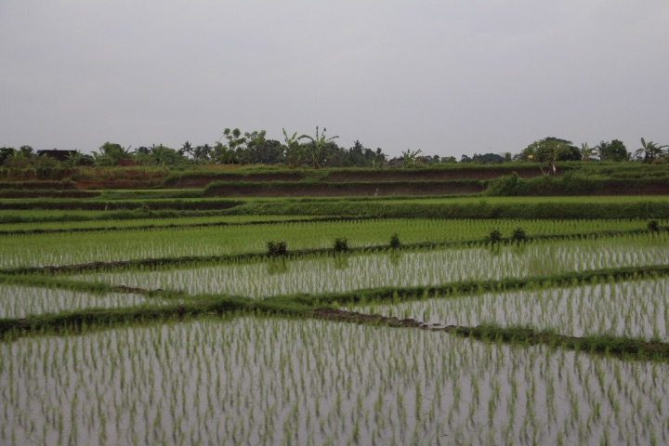
Can you draw a picture that shows positive and negative space?
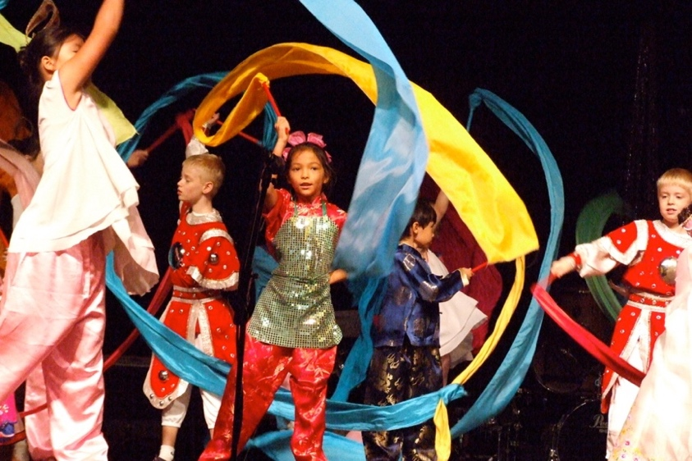

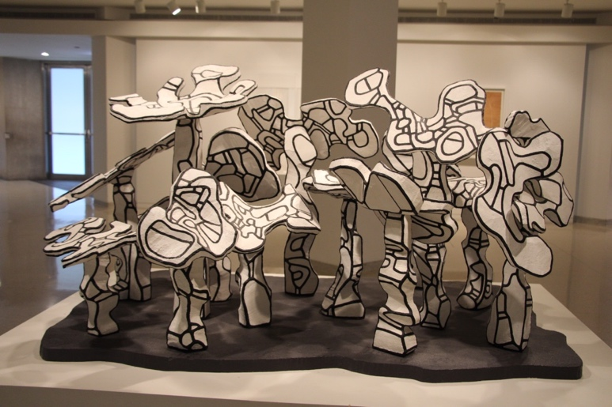
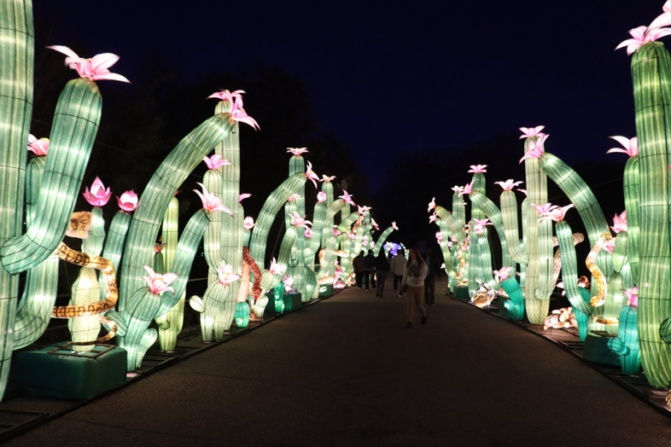
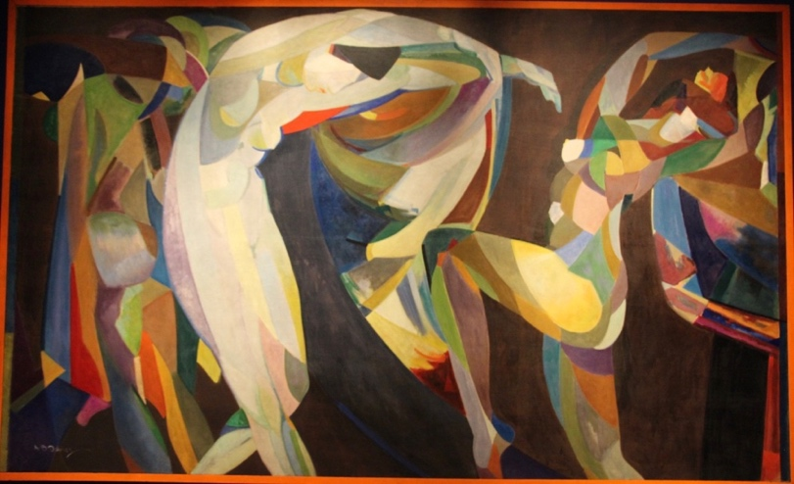

Discussion
Connect: How are the ideas and information presented CONNECTED to what you already knew?

Extend: What new ideas did you get that EXTENDED or pushed your thinking in new directions?

Challenge: What is still CHALLENGING or confusing for you to get your mind around? What question, wonderings, or puzzles do you now have?

