Lesson Title: | Signs of Life | Sample image  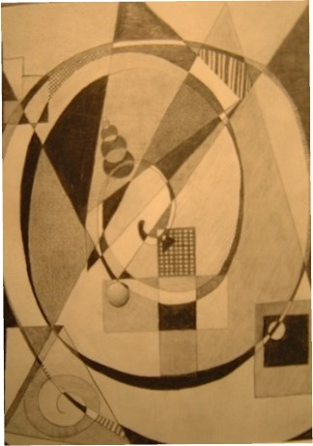
Time Frame | 1.5 Hours
Domain | Creating
Standard | Crl.1
Essential Questions | How does understanding shapes and the elements and principles of Art affect the creation of original works of Art/Design?
Objectives | Participants use different shapes (Circle, Square, Triangle, Equilateral Cross and Spiral), art elements (Values, Textures) and Techniques (Shading, Hatching, Crosshatchings, Torn papers) to create an original drawing.
Procedures | Students will use different shapes (Circle, Square, Triangle, Equilateral Cross, and Spiral), art elements (Values, Textures), and Techniques (Shading, Hatching, Crosshatchings, Torn papers) to create an original drawing.  Students will use their understanding of Contrast to create movement in their composition.
Thinking and Problem Solving/ Studio Habits | Students will develop a design based on selected shape/shapes that reflect skills and understanding of the shapes' meaning and the elements and principles of art. Students can express their thinking verbally or in writing in the development and meaning of their work.
Materials | For our session, you will need drawing paper, a 4B pencil, a ruler, and a classroom-grade compass. If time permits, we will use these shapes for a watercolor or Acrylic painting. For the painting, you will need a set of watercolors: 140 lb of watercolor paper or a set of acrylic watercolor paper or canvas.
References | Lesson was inspired by the Book Signs of Life by Angeles Arrien  Works of Wassily Kandinsky

