TENNESSEE ARTS ACADEMY

2022 WINTER WORKSHOPS

OIL PAINTING WORKSHOP
VALUE STUDY

February 26, 2022

CORE SESSION 1 9:00 to 10:30am

CORE SESSION 2 10:45 to 12:15pm

INTERLUDE: SNOWFLAKES 2:15 – 3:00PM

Introductions:

PowerPoint ARS 210 Beginning Painting at UAB
PowerPoint Value Study

Demo Various techniques, rags, q-tips, plotting vs brushing, additive and abstractive,

PowerPoint Intermediate & Advanced Painting at UAB (time permitted)

Artist/Professor Gary Chapman

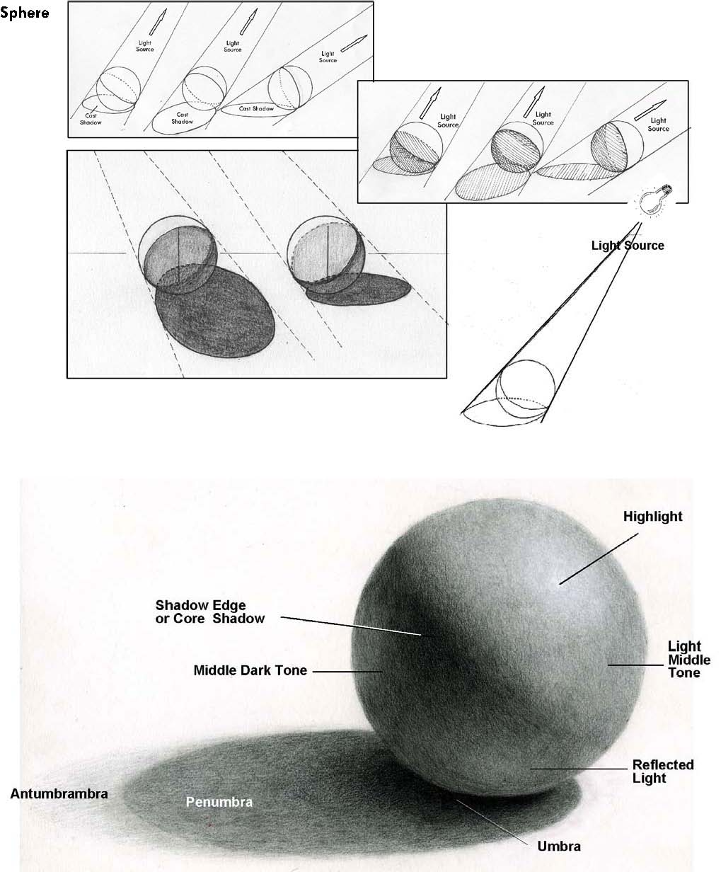

Highlight, Body of Light, Reflected Light, Body of Shadow, Cast Shadow, full range of edges and transitions

THE MANTRA:

It is with the contrast of:

light with dark value/chiaroscuro
sharp edges with soft edges focus
intense color with muted color intensity
warm color with cool color temperature
thin paint with thick paint texture
transparent paint with opaque paint opacity

the keen observation of these factors; coupled with fine draftsmanship and a good understanding of linear perspective, that objects are distinguished from each other and their environment, and a convincing illusion is created.

“FIRST, and if nothing else, come out of here knowing how to paint.”

“SECOND, always know that the ultimate goal should be to find the voice that distinguishes your work from others.”

“THIRD, find within yourself that which will drive you to make your work when so many others will stop.”

Gary Chapman
Artist/Professor

ABOUT OIL PAINT:

PAINT: can be divided into two basic components
PIGMENT is the dry powder from raw materials and source of color, either natural or synthetic.

VEHICLE is the liquid medium used to move the pigment around and to secure its particles to each other and to the ground.

The vehicle has four basic functions:
Executive: to move it around
Binding: so that the pigment particles dry in a single mass
Adhesive: so that the paint mass adheres to the ground
Optical: to provide the full intensity of light and color

Oil paint does not actually dry, but rather goes through a chemical change, which is irreversible. It is known as a thermoplastic film-former.

MEDIUM: Keep it simple. Avoid the romantic concept of a secret or ancient formula.

Painting is easy today because of experience and the benefit of time, technology, and the competition to create the best paint. Today paints are far more consistent in oil content and archival permanence. It would be ideal to paint with out a medium at all because so much effort has been put into the commercial paint to make it last in its pure form. To alter its structure with any additives is to endanger its archival expectations. However, most find a medium necessary for a full range of techniques and effects or to extend the properties and potential of the paint.

MINERAL SPIRITS: (Odorless) 80 to 70 % MORE
LINSEED OIL: (Artist grade only) 20 to 30 % LESS Mark this Jar as MEDIUM

You will have a second jar of just Mineral Spirits Mark this Jar as SPIRITS

The mineral spirits will help to liquefy the paint so that it will flow better. What actually is happening is the breaking down of the oil content, and here is where the danger lays. The linseed oil is added to restore the oil content, thereby restoring its archival potential. Gum Arabic is sometimes added to further restore the adhesive properties.

DEMONSTRATE:
Opaque verses Translucent Wet stroke verses Dry
Sharp edge verses soft , how to zip and edge, and how to obliterate and edge
The palette knife
Saving your paint clear plastic wrap
Your easel
Cleaning, taking care of and storing your brushes

VOCABULARY LIST
ARS 210 BEGINNING PAINTING

COLOR/DESIGN
ANALOGOUS A range of colors which share a common color.
ASSYMETRICAL Not the same on either side of an axis (but not necessarily out of balance).
ATMOSPHERIC PERSPECTIVE The illusion of depth on a 2D surface by simulating the illusion that with distance objects appear to soften at the edge, lighten in value, and take on a bluish tone.
BACKGROUND The most distant zone of space in a three-dimensional illusion.
BLACK (pigment theory) The presence of all color.
COMPLEMENTARY One primary color and the secondary color which is created by the other two primaries. Two colors which basic components complete the primary color spectrum.
COMPOSITION The combination and placement of elements in a work of art which are determined satisfactory to the artist.
COOL COLOR A color which suggests sensations of coolness such as blue or its associated hues blue-green and blue-violet. In
general cool colors appear to recede from the picture-plane and therefore suggest depth.
FOCAL POINT The area in a pictorial composition to which the eye returns most naturally.
FOREGROUND The closest zone of space in a three-dimensional illusion.
FORESHORTENING When the longest dimension of an object is at an angle to the picture plane.
FORMAL Refers to an emphasis on the organizational form, or composition, of a work of art.
HUE A color. A compound color in which one of the primary colors predominates.
INTENSITY The brilliance of a particular color; pureness.
LINEAR PERSPECTIVE A system which creates the illusion of depth on a 2D surface by simulating the illusion that parallel lines which recede in space appear to converge at a shared vanishing point.
LOCAL COLOR The color of a particular object as seen in daylight against a white background irrespective of surrounding influences such as shadows and reflections. True color.
MIDDLEGROUND The intermediate zone of space in a three-dimensional illusion.
PICTURE PLANE The imaginary plane represented by the physical surface (canvas, paper, etc.) of a painting.
PRIMARY COLOR Red, Yellow and Blue. The colors from which all others are derived, and which cannot be decomposed into other colors.
PROPORTION The ratio between the respective parts in a building or any work of art.
SECONDARY COLOR Green, violet and orange. A color produced by mixing equal proportions of two of the primary colors.
SYMMETRICAL A composition which is the same on either side of an axis, thus creating balance.
TERTIARY A color produced by mixing two primary colors in unequal proportions.
TEXTURE The nature of the surface of a work of art. The rhythm of the brush-strokes in a loosely handled painting.
TINT The dominant color in a mixture of colors, or a mixture of a color and white.
TONE The comparative brightness or dullness of a color. The predominant color in a picture.
VALUE Black, white, and the gradations of gray tones between them. The relationship in a painting between tone and hue.
VANISHING POINT The point of which a set of lines, which in reality are parallel to each other, seem to converge.
WARM COLOR A color which suggests sensations of warmness such as red and yellow. In general warm colors advance from the picture plane.
WHITE (pigment theory) The absence of color.

PAINT ETC.
BINDER Any substance mixed with pigment in order to make it adhere to a surface.
FAT OVERL EAN The painting process which assures archival permanence whereby paint which is layered is always
applied from the thinnest layer underneath, up to the thickest layer on the surface, as well as the least oiliest below up to the oiliest on the surface.
GESSO A white ground, now usually acrylic based, which sizes the canvas and provides a non-absorptive, bright white ground to paint upon.
GROUND A surface specially prepared for a painting, perhaps with gesso or a layer of paint in an even tone.
MEDIUM (formula) Linseed oil and mineral spirits (50 - 50). The liquid in which pigment is suspended in any kind of painting.
PIGMENT The coloring agent in a paint or dye, natural or synthetic.
STRAINER The wooden framework to which a painter’s canvas is attached, and unlike a stretcher, once the canvas is stretched and applied is permanent offering no means of expanding the structure to tighten a loosened canvas.
STRETCHER The wooden framework to which a painter’s canvas is attached, and unlike a strainer, once the canvas is stretched and applied it may be expanded to tighten a loosened canvas.
VEHICLE The medium or combination of medium and binder which carries pigments in suspension, and enables them to be applied and adhere to a surface.
TECHNIQUES & DESCRIPTIONS
ACADEMIC Formalistic, conventional. A process or theory which can be taught or learned. A characteristic pertaining to a school of thought.
ALLA PRIMA Method of painting a picture in one layer of pigment without use of underpainting, glaze or retouching.
CHIAROSCURO An exaggerated use of extreme contrasts of light and shade in painting and drawing.
COMBINE PAINTING An extension of collage, when flat and 3-D objects are attached to the painting surface and sometimes painted over.
CONTRAPPOSTO A way of representing the body so that it is obliquely balanced around a central vertical axis, the torso twisting away from the legs.
DIP TYCH A pair of panels which make up one piece of art.
DRY BRUSH PAINTING The very scanty use of paint upon a textured surface, the paint clings to the raised parts of the surface.
ECLECTIC Consisting of an amalgam of elements from other styles.
FORESHORTENING The depiction of an object at an angle to the picture plane, by means of linear perspective.
FRESCO Painting done with mineral or earth pigments onto wet plaster.
GESTALT A total mental picture, or conception, of a form.
GESTURE A spontaneous and fluid representation of the dominant physical and expressive attitudes of an object or space.
GLAZING Transparent layers of paint layered over top of other colors or ground which modify the color.
ICON An image or symbol, regarded as sacred, often conforming to a particular religious doctrine.
IMPASTO The texture produced by the thickness of paint applied.
IMPRIMATURA A wash or thin glaze of color used to tone down the white ground before painting on it. A base coat.
KITSCH Mass-produced art and artifacts unsuccessfully aping the aesthetic standards of elite culture.
MODELING The representation of 3-D forms in two dimensions so that they appear solid. (Light and shadow.)
NON-OBJECTIVE A style of art in which the imagery is solely the product of the artist’s imagination, and therefore without reference to things in the real world.
OBJECTIVE Uninfluenced by emotion or personal prejudice.
PAINTERLY A technique which balances concern for illusion and process of paint.
UNDERPAINTING The underlying coat of paint intended as a base sketch to work from, or fields of color which are planned to assist in creating complex colors through light and glazing techniques.
PASTICHE A work which openly imitates previous work, sometimes with satirical intent.
PLASTICITY The real or apparent three dimensionality (movement) to a work of art; giving form or shape to a substance.
PLEIN AIR Painted out of doors. Landscapes which are painted from direct observation of the land, outdoors.
POLYPTYCH A painted work of art which is composed of many panels.
PREDELLA A painting placed beneath the main scene or main series of panels in an altarpiece.(usually horizontal and narrative.)
SATURATION The brilliance of a color, the pureness and intensity of the color.
SCUMBLING The uneven working of a thin layer of color over another, giving a broken rough effect, dry brush.
SERIAL IMAGERY The same image repeated several times with slight variation.
SFUMATO Transitions from light to dark which are so gradual as to be almost imperceptible.
SGRAFFITO The technique of scratching through one layer of paint(color) to reveal another.
SPREZZATURA The quality of cultivated carelessness which distinguishes a sketch, gestural.
STIPPLING Paint used in small dots or dabs so as to produce a dappled effect.
SUPPORT The material (canvas, wood, etc..) on which a painting is done.
TENEBRISM Art emphasizing night effects and strong shadows.
TOOTH The slight roughness of a canvas or support which enables paint to cling to it more firmly.
TROMPE-L'OEIL Painting which uses various illusionistic devices to convince the viewer they are looking at the actual object, thus usually creating a very shallow but highly illusionistic space.
VERISM The attempt to reproduce reality in art with rigorous and unselective accuracy.

MISCELANEOUS
AUTONOMOUS Independent. Not pertaining to the laws of any other state or reality beyond itself. Paint for paint sake.
CONTENT The meanings inferred from the subject matter and form of an artwork.
CROPPING Using a format to mask out parts of a subject matter image.
SUBJECT MATTER The intent of the artist, content.
ZEITGEIST The spirit of the time, the taste and perspective of a period or generation.

These definitions have been compiled from the following sources: “The Thames and Hudson Dictionary of Art Terms”, “A Visual Dictionary of Art”, and the common sense of Gary Chapman.

INTERLUDE: SNOWFLAKE WORKSHOP

Students will learn to fold and cut simple white copy paper, creating a 6-point snowflake. After learning the basics, students will better understand the variables that go into creating rather complex and creative designs. A PowerPoint will be running throughout the workshop showing 100’s of unique snowflakes cut by the instructor.

https://www.thecraftaholicwitch.com/3d-paper-snowflakes/

https://www.youtube.com/watch?v=9ua_tS8Zmv8
folding and cutting

